**Gantt Chart**

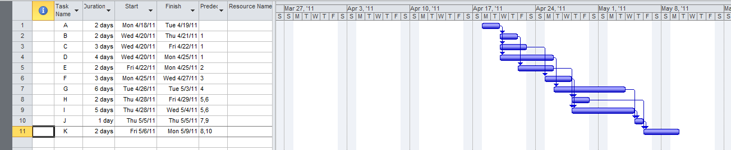

**Network Diagram (PERT Chart)**

